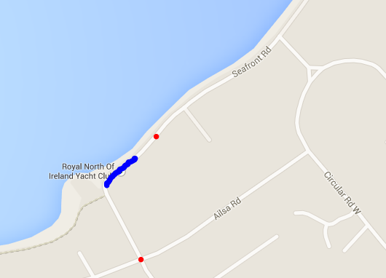

B

A

**Arrival and departure**

**Voluntary one way system between points A and B**

**Unloading Bay (Unloading only – NO PARKING!!!) Not even 5 minutes.**

**Road Trailer Parking 150 yards this way on right. Limited space, so if you can take your trailer away it would be appreciated.**

**Arrival and departure**

**Voluntary one way system between points A and B**