Welcome Parents and Sailors to the 2017 Crosbie Cup held in Sutton Dinghy Club located on the Sunny Side of Howth Peninsula.

• We hope you enjoy the event and that weather will be favourable. In order to make your visit to Sutton Dinghy Club as enjoyable as possible we have put together this information pack.

**Sutton Dinghy Club Strand Rd, Sutton, Dublin 13, Ireland**

**Getting to Sutton Dinghy Club**

• On the south side of the Howth Peninsula, with easy access to the whole of Dublin Bay - or to the sheltered waters of Sutton Creek.

• 15km from Dublin city centre and 1km from Sutton Cross. Just keep the sea on your right and follow the coast road. You can't miss us!

**When you get here**

Boat Parking

• When you get to SDC there will be signs indicating where to park your boat. Please follow the directions of the car park attendants. Please park your boat and accessories with consideration for other sailors. There are no vehicles or road trailers allowed in the boat park. You will have to off load in the car park or in the boat park. Then move the trailer as advised by instructions below.

Car Parking

• Car Parking is not available at the club during events but there is parking on the roads around the club. Please follow the directions of the attendants and with consideration for other visitors and access for emergency services.

Rib Launch

• If you intend to bring a Rib we would request that you launch it in Howth Harbour at the public slip. Sutton Creek is Tidal so we would recommend keeping your rib in Howth Overnight there is mooring available in Sutton but they are moored at your own risk.

Trailer Parking

• Trailers will need to be removed from the area and parked at Sutton Park School which is located close to the club. You will be directed to Sutton Park school by the car park attendant. Again please park your trailer with consideration for others.

• This area will be secured through Saturday Night.

|  |
| --- |
| **LOCAL ACCOMMODATION**  **SUTTON AND HOWTH AREA**  **HOTELS:**  Marine Hotel Sutton Cross, Sutton, Dublin 13 (01)8390000  GUESTHOUSES:  The King Sitric East Pier, Howth, Co. Dublin (01)8325235  **BED AND BREAKFAST - SUTTON:**  Aaron House, 778, Sarto Park, Bayside, Sutton, Dublin 13 (01) 8391838 Andrew & Helen Webster,  83 Offington Ave, Sutton, D13 (01)8393585 www.cornerville.net  Eileen & Tom Staunton, 20 Offington Drive, Sutton, D13 (01)8324442 info@azure.ie  Margaret & Jo Lynch,Clogheen, 87 Dublin Road, Sutton, D 13 (01)8322809 Mary McDonnell, “Dun Aoibhinn”, 30 Sutton Park, Sutton, D13 (01)8325456 [marymcdonnell@ireland.com](mailto:marymcdonnell@ireland.com)  Frances Kelly-Mor, 13 Shelmartin Road, Sutton, D13. (01)8324233  **BED AND BREAKFAST – HOWTH**  Margaret Campbell, Highfield, Thormanby Road, Howth, Co Dublin (01)8323936  Kitty Rickard, Gleann-Na-Smol, Nashville Road, Howth, Co Dublin (01)8322936 discoverireland.ie  (under Gleann-na-Smol)  Carol & Miles Cronan , Charlston, 97 Howth Road, (01)8390184  Ann's, 5 East Pier, Howth, Co Dublin (01)8323197 [www.annsofhowth.com](http://www.annsofhowth.com)  **Discover Ireland – accommodation in area**  [**www.discoverireland.ie**](http://www.discoverireland.ie) |
| **Shops**  **Supermarkets**  • There is a SuperValu in Sutton Cross ~1km from Club  **Local Shops**  • Howth Village has a selection of shops and pubs and restaurants.  ***Dublin City***  • The City is about 30 minutes by DART, Sutton Train Station is about 2km from the club |

Tides

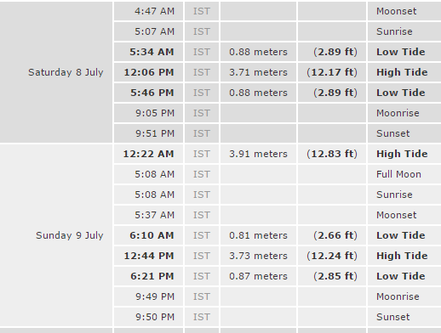

Location:

