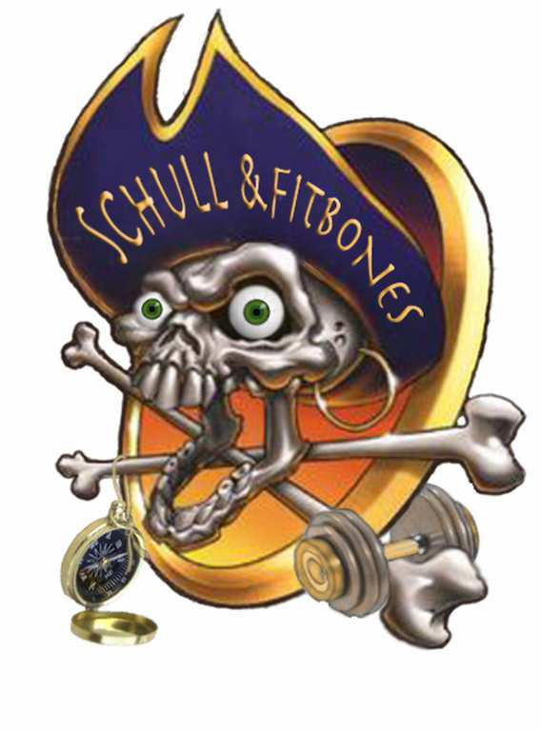
Not Sailing?

The fun and adventure is all yours, kids

3 days of outdoor adventure for non-sailing kids, with by Schull & Fitbones

@ IODAI BALTIMORE 2018

Day 1. Sherkin Island and BBQ.
- We meet at the pier in Baltimore to catch the 10.15 ferry to Sherkin Island.
- Once on the island we walk to silver strand and explore along the way. On the beach we have fun and games, and roast marshmallows on the BBQ. Yum!
- Bring small rucksack with lunch / drink. Dress for weather.
- Pick up from pier at 2.30pm

Day 2. Beacon Hike and Playground Fun
- We meet 10am at the car park by the Beacon - 1 mile form Baltimore.
- We hike along tracks and trails and can even do a bit of camping so we have shelter for lunch! Then back to the playground for some orienteering, parachute games etc.
- Bring small rucksack with lunch / drink. Dress for weather.
- Pick up form the Playground at 2pm

Day 3. Lough Hyne Woods Adventure Challenge.
- Meet 10am by car parking area at Knockomagh Woods by Lough Hyne - 3 miles from Baltimore. We can supply directions!
- We have a series of challenges along the way to the top, including Wild Whoozy, rope climb, blindfold trail, slacklining. And for kids who like to bathe in mud - usually there is plenty at the summit.
- Bring small rucksack with lunch / drink. Dress for weather. Parents - bring a FULL change of clothes when collecting kids (and large plastic bags for muddy clothes / muddy kids). We do not guarantee clean kids.
- Pick up from carpark at 2pm

AGES 5+

Programme subject to change depending on weather

Contact Deirdre on 086 2404709 / deirdrenc@gmail.com to book your child /children
www.fitbones.ie; www.facebook.com/SchullandFitbones

We will also be at registration on the Saturday / Sunday

€60 - 3 days; €25 - single days

