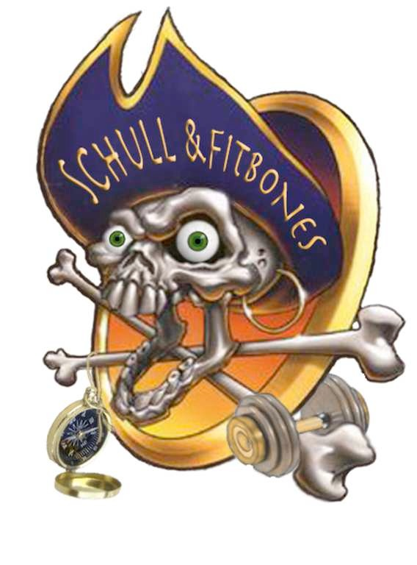
SCHULL & FITBONES
IODAI MIDTERM ADVENTURE 2018
Registration Form
Name of child (children)
Age(s)
Contact name and number
Address
Email
Any known medical conditions/special needs of which we should be aware?
Activities
Sherkin Island trip  Meet at ferry pier | Tuesday 13th Feb  10.15 – 14.15
Baltimore hike and playground orienteering and fun | Wednesday 14th  10.00 – 14.00
Lough Hyne Adventure Challenge | Thursday 15th February  10.00 – 14.00

We compile a selection of photos we take to showcase the various activities we do for marketing of Schull & Fitbones only. If you do not want your child’s picture to be included please let us know.

Please make cheques payable to: Schull & Fitbones
Send to: Castlepoint, Schull, Co. Cork, Ireland

Or Bank Transfer to Schull & Fitbones: IBAN IE66AIBK93636701658154 ; BIC AIBKIE2D

