IODAI BALTIMORE DISCO

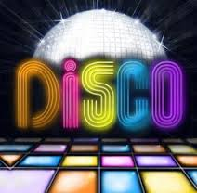

THURSDAY NIGHT 7.30 TO 9.30PM.

DRESS TO IMPRESS – IF YOU WEAR IODAI 2018 GEAR, YOU GET IN FREE OTHERWISE COST €3

