

25th – 28th April 2019

Royal Cork Yacht Club

General Event Information for Competitors

CONTENTS

WELCOME/ARRIVAL

GENERAL INFORMATION

REGISTRATION and BRIEFINGS

EVENING SCHEDULE

CLUB FACILITIES and LOCAL INFORMATION

Welcome!

On behalf of the Royal Cork Yacht Club, Irish Sailing, and IODAI you are welcome to the IS Youth National Championships and Optimist Trials 2019. We intend to run a championship in a safe environment for all sailors with great racing in Cork Harbour.

We hope that you, the sailors, your parents, families, friends and coaches have a wonderful time in Crosshaven during your stay.

As visitors to the RCYC please feel free to enjoy the club's facilities and traditional hospitality.

Our Club staff and Organising committee will be available during the event to assist you in any way possible.

Contact numbers

RCYC Office: +353 21 483 1023

ARRIVAL

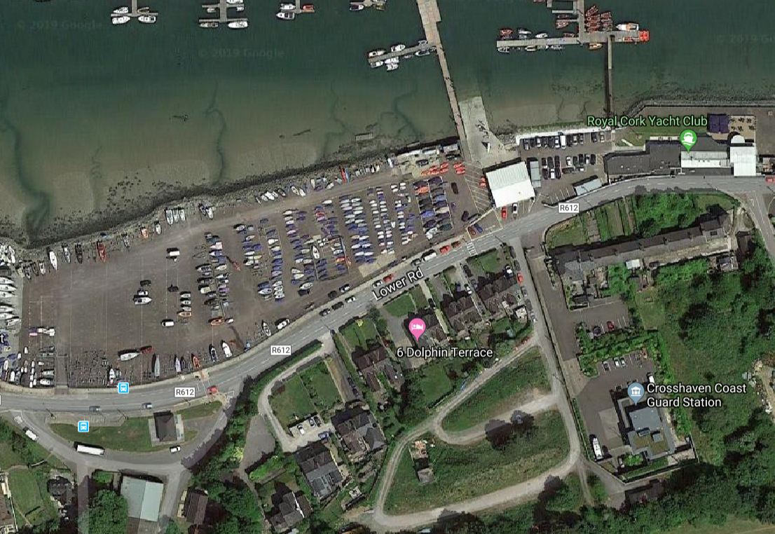
Oppies
Radial/ 420
Car Park
Topper/4.7

Dinghy Unloading Area
RIB & Dinghy Trailer Storage
Campers
RIB Launch

Race Office
Club House

Optimists
Clearway

Laser Radials
420
Car Park
Toppers 4.7

Dinghy Unloading Area
RIB & Dinghy Trailer Storage
Camper Vans

Traffic Management
RIBs
All RIBs must be launched from the main club slip before 9am on any given day. Otherwise, RIBs can be launched from the public slip (just past Crosshaven Boatyard). Access will be permitted again once the fleet are afloat. There will be no slipway access while the fleets are launching or retrieving.
A one-way system will be in place for launching RIBS as outlined in Red in the map. Please come in the Car Park Entrance gate and proceed along the water’s edge. You may unstrap & prepare your rib just west of the slipway. Once launched, there will be a hose available to rinse trailers as you exit through the gate adjacent to the Race Office. There will be no loitering on the slip - if you are not ready to launch or recover there will be a holding area near the slip head.
Trailer storage (unsecured) is available directly across the road from the main slip on two levels as shown.
Ribs may be recovered while the fleet are afloat on Sunday or after they are all ashore.

Dinghy Trailers
Dinghy trailers will not be allowed into the compound. Please unload your dinghy trailer across the road from the main gate. Cross the road with your dinghy into the location as noted on the map and move the trailer to the Trailer storage area to leave the Car park free for Cars for the event. (Exact locations for Toppers/4.7/Radial/420 may change but will be signposted)

Boat Parking
- Competitor boat parking is in the designated areas. It is important that all sailors place their boats in the correct area when coming ashore each evening.
- RIBS will be berthed on the marina (spaces will be allocated at registration).

Car Parking
There are a limited number of complimentary daily parking spaces within the club. There is public car park in the village which is free.

Fuelling
Please speak with a member of shoreside staff to arrange fuelling your RIB. Payment can be arranged via the RCYC bar.

Motorhome Parking
There are 12 spaces available for motor homes and must be booked prior to arrival by emailing office@royalcork.com. There is a fee of €10 per night including electricity. On arrival please check in with the RCYC main Office to obtain your permit.

Camping
Limited pitches will be available on site but must be booked by emailing office@royalcork.com. On arrival please check in with the Main Club Office to obtain your permit.

GENERAL INFORMATION

General Information
- The Race Office will be situated in the Dinghy Centre adjacent to the Dinghy Park and will be open from 4pm to 8pm on Wednesday 24th April and from 8am on Thursday, Friday, Saturday and Sunday.

Sailors of the Sea – Clean Regatta
- This event is a registered “Clean Regatta” with Sailors of the Sea. Every boat, no matter how big or small can help protect the ocean. Please reuse, recycle and reduce.
- We ask that all sailors and volunteers please bring your own reusable water bottle for the course of the event. There will be 2 designated hydration stations, where you can refill water bottles at the club.
- All takeaway cups and lids in the RCYC are biodegradable and compostable.
- For more information on Sailors for the Sea please go to http://www.sailorsforthesea.org

Showers & changing rooms
- Available to sailors for the duration of the event, please remember that RCYC is not responsible for any valuables left unattended.
- Adult changing rooms (closest to the main club house): Are to be used by all sailors age 16 and over.
- Dinghy Centre changing rooms: Are to be used by sailors age 15 and under.

Catering
- Catering will be available each day in the RCYC clubhouse.
Thur 16.00hrs -20.00hrs
Fri 16.00hrs-21.00hrs
Sat 11.00hrs-21.00hrs
Sun 11.00-20.00hrs.
- Hot refreshments will be served to sailors each day after sailing.

Briefing Location
In front of main Clubhouse.

Notifications made ashore
The Official Notice Board will be located in the Race Office, situated at the Dingy Centre at the top of the slipway.

Chandlery
Local chandlery suppliers include CH Marine, Frankfield Industrial Estate and Union Chandlery, Doughcloyne Industrial Estate.

Personal Belongings
No personal belongings should be left in the changing rooms or the Clubhouse overnight. Valuables should not be left in the changing rooms or unattended. The Club will not accept any responsibility for the loss or damage of any personal items.

Lost & Found
There will be a lost and found “box” in the Race Office.

Wi fi
Free Wifi is available in the RCYC clubhouse.

Commercial Shipping
Cork Harbour is used by a large number of commercial ships and recreational vessels. Guidance notes for leisure craft using the harbour is available on www.portofcork.ie

Weather and Tidal Information
- For up to date weather and tides – visit The Irish Meteorological Service online.
- General Forecast information – www.met.ie
- Sea area forecast http://www.met.ie/forecasts/sea-area.asp

Race Areas
To be advised

Child Protection Officer
If you have a concern please contact the RCYC Children’s Officer Dr.Larrie Martin on 087-2527 800 who will respond quickly to your concern or complaint according to our policy and using guidelines, policies and procedure specified in the IS Code of Ethics and Good Practice for children’s activities.

REGISTRATION, BRIEFINGS & EQUIPMENT CHECKS

Registration

Day/Date | Schedule | Time
Wednesday 24th April | Registration - 420, Laser Radial, Optimist  Optimist Equipment Measurement (in club dining room) | 1600-2000
Thursday 25th April | Registration - 420, Laser Radial | 0830-1000
 | Competitor briefing – Optimist | 0945
 | Competitor briefing 420, Laser Radial, | 1015
 | Mandatory support boat briefing | Immediately after
 | Registration - Laser 4.7, Topper, Topper 4.2 | 1600-2000
Friday 26th April | Registration - Laser 4.7, Topper, Topper 4.2 | 0830-1000
 | Competitor briefing - Laser 4.7, Topper, Topper 4.2 | 1015
 | Mandatory support boat briefing - Laser 4.7, Topper, Topper 4.2 | Immediately after
Sunday 28th April | Prize giving | 1600 or earlier if  notified

EVENING SCHEDULE

A lineup of evening speakers – open to all:

At 5.30pm each evening or after racing there will be a talk and Q&A session at the club with speakers who have a deep knowledge of sailing and racing. The talks are open to all sailors and parents.

Thursday 25 April: Katie Tingle (Irish Sailing Team): “A second chance – taking the long view on a sailing career”

Friday 26 April: Séafra Guilfoyle (Irish Sailing Team): “My journey so far from Optimist nationals to 49er Championships”

Saturday 27 April: James O’Callaghan (Irish Sailing Performance Director) talks to Jessie Barr (Irish Sailing Academy and Sport Ireland sports psychologist) about “Resetting and refocusing during competition”

Sunday 28 April: Prizegiving

LOCAL INFORMATION

Emergency
Phone Number - Dial 999 or 112

Pharmacies
O’Regan’s Pharmacy, Ballea Road, Carrigaline 021 491 9640
Crosshaven Pharmacy, Point Road, Crosshaven 021 483 1200

Doctors
Dr Larrie Martin, Crosshaven Surgery, Point Road, Crosshaven 021 483 1315
Dr Vivian Foley, Owenabue Medical Centre, Ballea Road, Carrigaline 021 437 4997

Banks
AIB Bank, Carrigaline 021 437 2145 (ATM)
Bank Of Ireland, Carrigaline 021 437 2639 (ATM)
Permanent TSB, Carrigaline 021 437 1551 (ATM)
Nearest ATM – Centra, Point Road, Crosshaven

Supermarkets
Centra, Point Road, Crosshaven 021 483 3727
Barry Collins’ Supervalu, Carrigaline 021 485 2244

Transport
Buses – Route 222 check http://www.buseireann.ie for schedule.
Taxi – available locally – enquire at Club Office.

